PRODUCT DESCRIPTION

TO: NATIONAL INSTITUTES OF HEALTH (NIH) NATIONAL CANCER INSTITUTE (NCI)
FROM: ID.ME
SUBJECT: “I DON’T LIVE IN THE UNITED STATES” FLOW
DATE: JULY 26th 2022
Below is the verification flow for a user to verify at NIST SP 800-63-3 IAL2/AAL2 when selecting “I don’t live in the United States”.
- Click on “I don’t live in the United States” when asked to choose a verification method
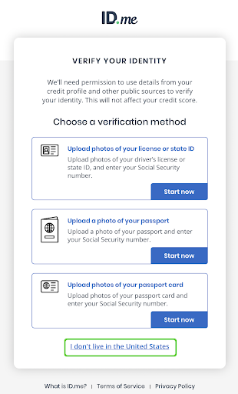

2. Select “Get Started”. Selecting this button starts the process to verify your identity on a video call.

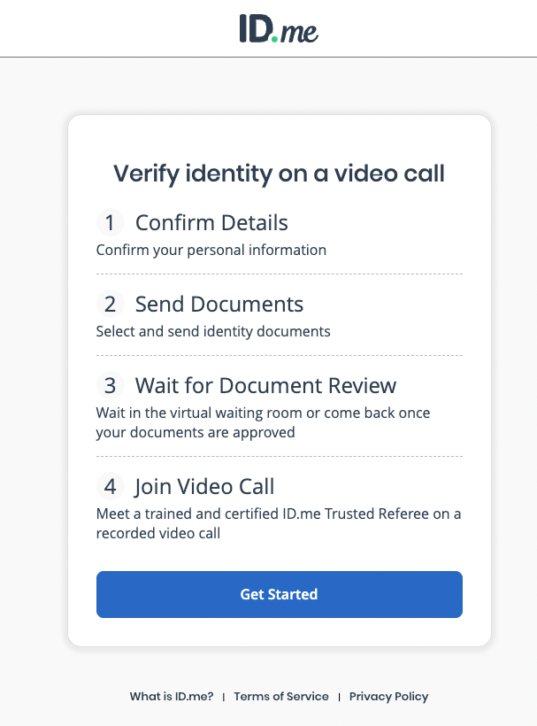

2. Read and consent to the ID.me Biometric Information Privacy Policy by clicking on the checkbox “I acknowledge that I have received, read, and agree to these terms” and click “Continue”.

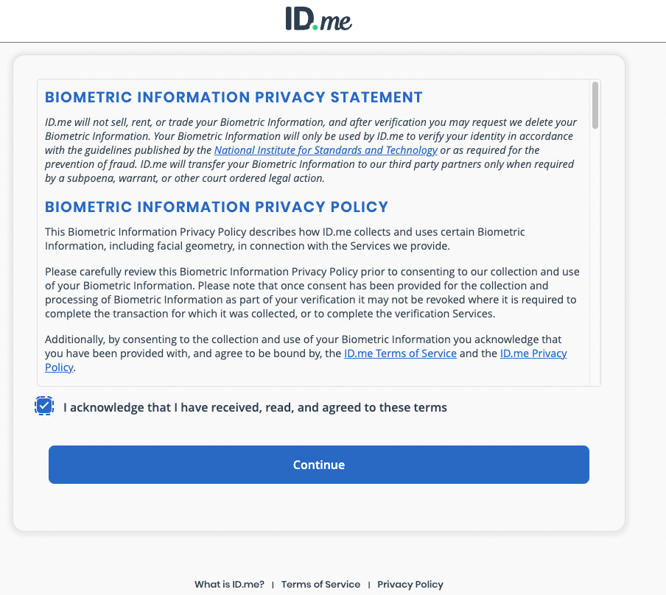

3. Ensure that the following information is correct: Full Name, Date of Birth, Phone Number, and Current Address. Click on “Continue”.

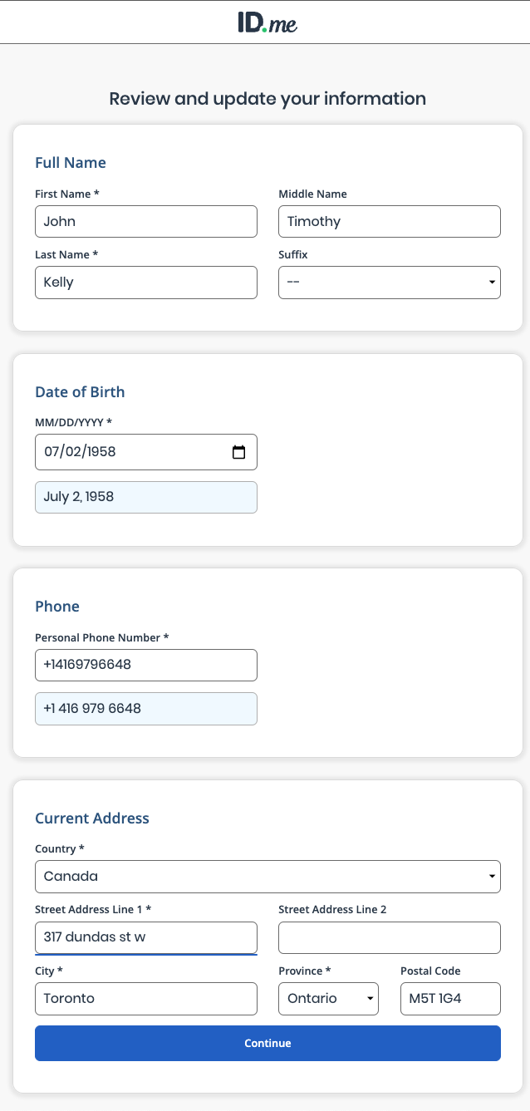

4. Enter your Social Security Number (SSN) or Individual Taxpayer Identification Number (ITIN)
- If you do not have a SSN or ITIN, you can check the “I have never been issued a U.S. Social Security number or Individual Taxpayer Identification Number checkbox.”

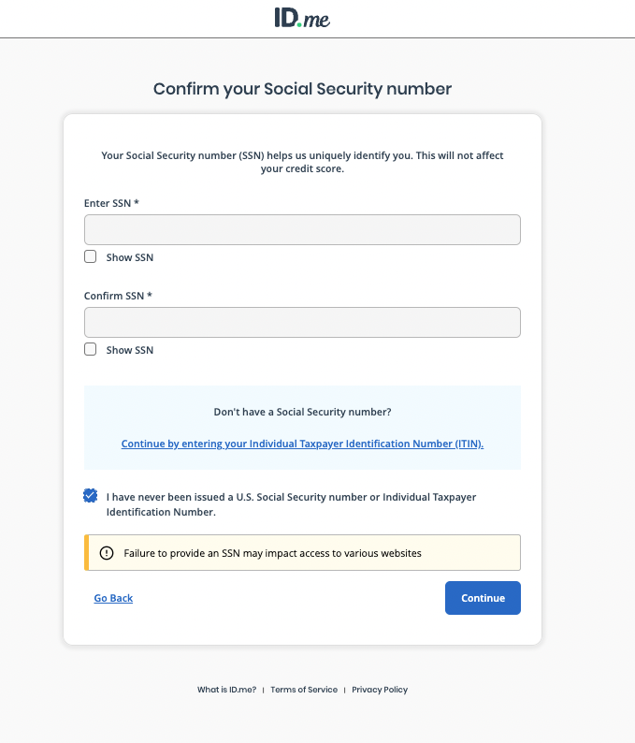

5. Enter your passport information and click on “Continue”.

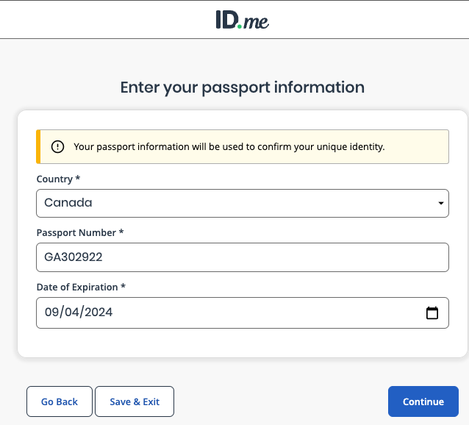

6. Gather all required documents, then click “Continue”.

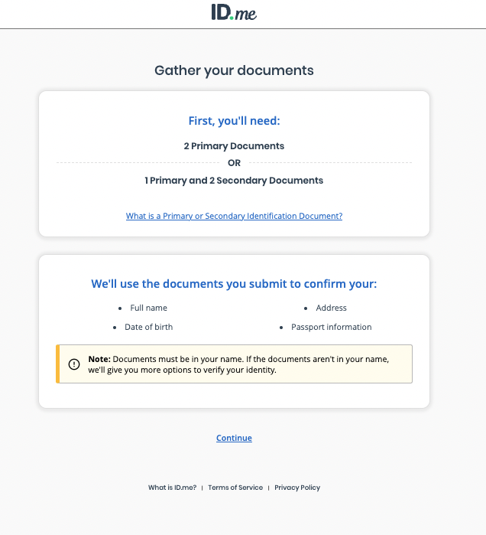

7. Confirm the name on your primary document and click “Continue”.

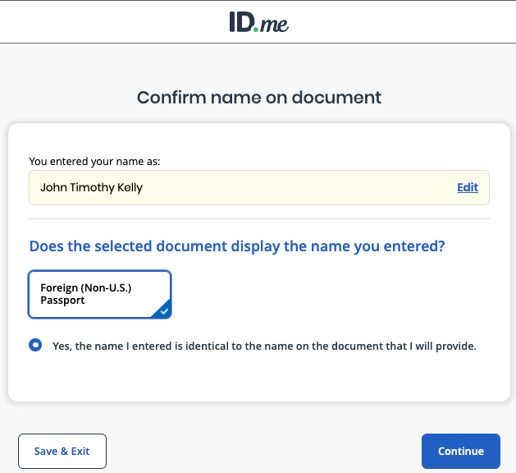

8. Select a secondary document containing the current address and click “Continue”.

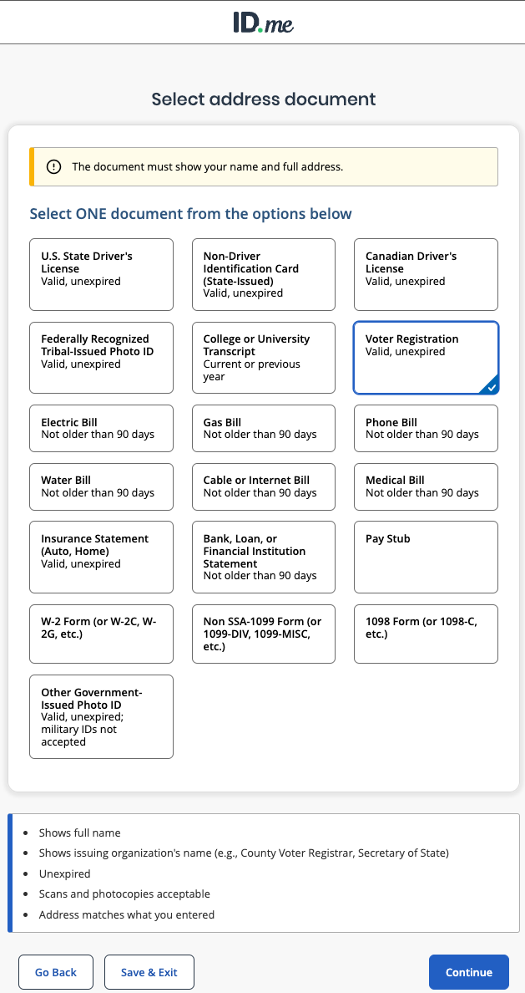
9. Confirm the name and address entered are the same as the document that will be provided

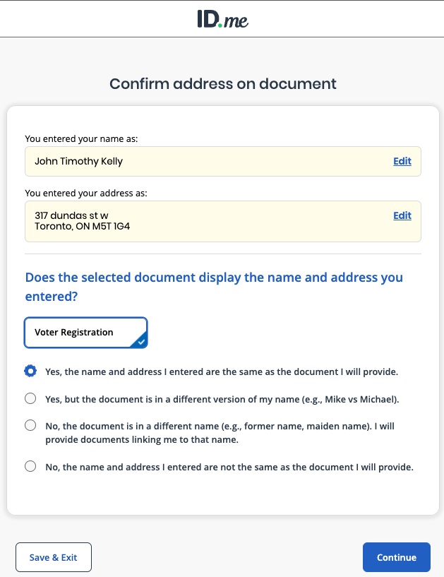

10. Choose whether to add one more primary or one more secondary document

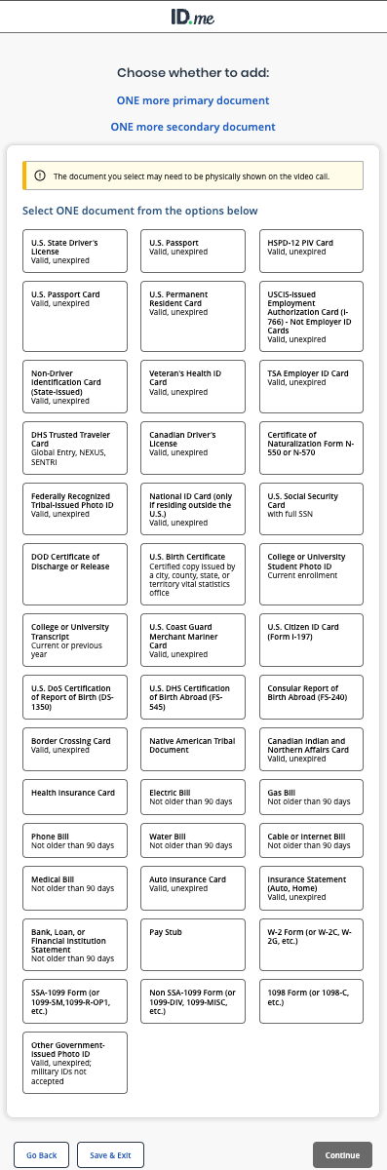
11. Confirm if the selected document displays the name you entered

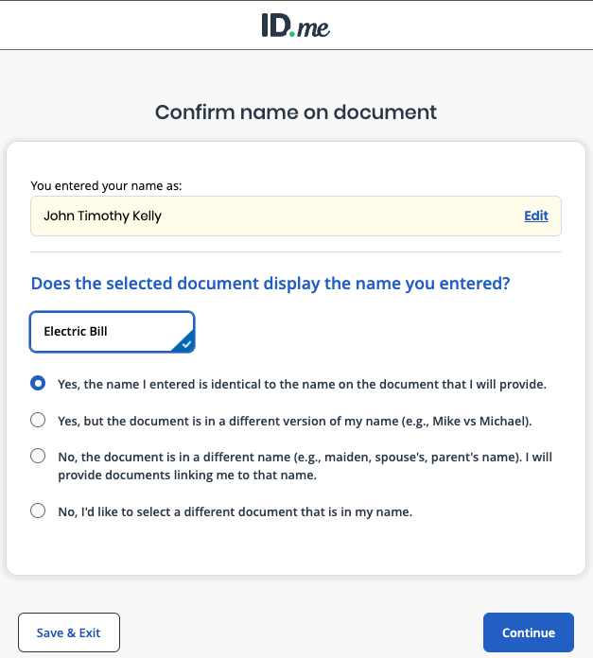

12. Upload an image or take a photo of your identity documents that you will share with the Trusted Referee

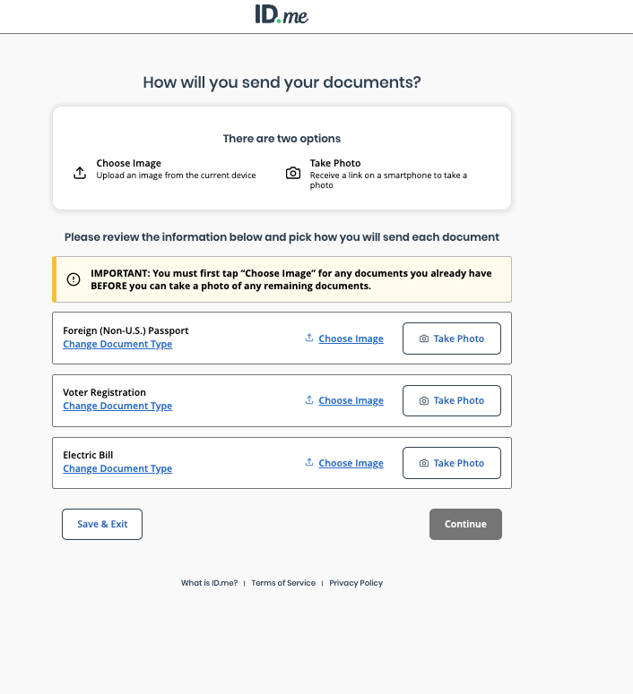

13. Review your personal information and chosen documents to ensure accuracy

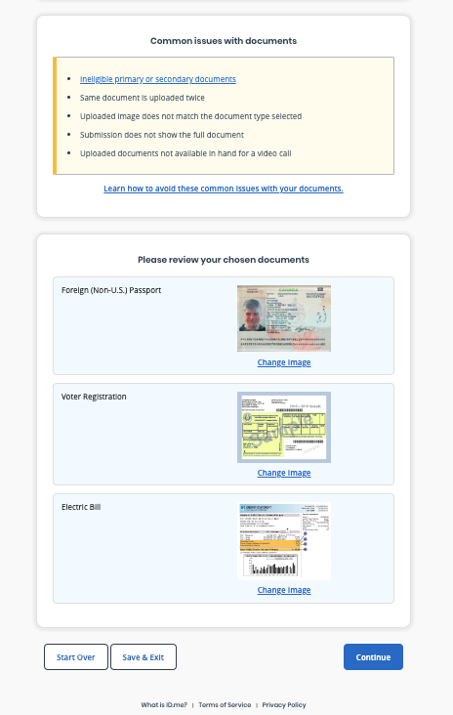

14. Once your documents are accepted, you will be prompted to start the video call with a trusted referee!

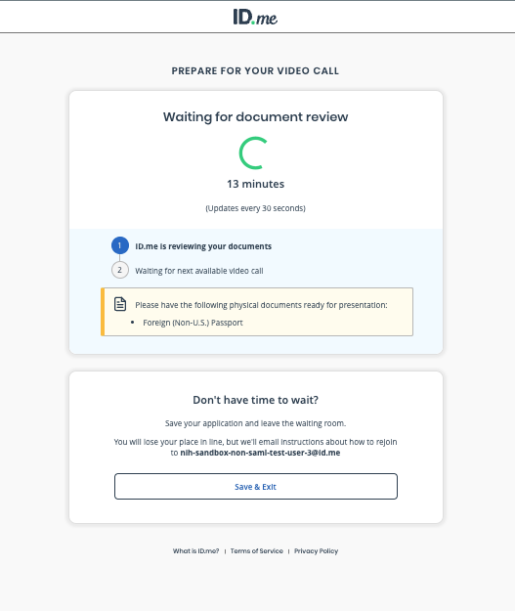

***
Thank you again for the continued partnership. We look forward to working together to create the best possible experience for NIH NCI users. If you have any follow-on questions, please contact Wes Turbeville (Vice President, Federal, wes.turbeville@id.me), Ben Piccarreta (Customer Success Manager, ben.piccarreta@id.me), or Jeremy Haynes (Senior Account Executive, jeremy.haynes@id.me).

Currently, ID.me does not yet offer the “I don’t live in the United States” link to all partners.

